**A Web-Based Warehouse Inventory Management System**

**For General Services Office**

An IT Project Proposal

Presented to the

Faculty of the School of Computing and Information Sciences

Saint Louis University

In Partial Fulfillment

Of the Requirements for the Course

IT 411

Ian Paul M. Alinso

Christian R. Beltran

Lemuel C. Estacio

Swira Claire L. Cogasi

Zsarlene Alyza D. Garcia

Jessirine Nichole M. Gueco

Fatima Mae C. Pascua

Rizalina N. Tubera

Randy Domantay

Project Adviser

November 2017

# **Table of Contents**

**Table of Contents** II

**List of Figures** IV

**List of Tables** VI

**Abstract** VII

**CHAPTER 1** 1

**INTRODUCTION** 1

**1.1** **Context of the Study** 1

**1.2 Background of the Study** 2

**1.2.1 Company Profile** 2

**1.2.2** **Office Operations** 3

**1.2.2.1** **Products** 3

**1.2.2.1.1 Procurement Issuance Process** 5

**1.2.2.1.2 Product Issuance Process of common office supplies, printer and photocopier consumables and janitorial supplies.** 6

**1.2.2.1.3 Product Issuance Process of office supplies with Inventory Custodian Slip (ICS)** 7

**1.2.2.2 Product Delivery Process** 7

**1.2.2.3 Returns** 7

**1.2.2.3.1 Purchase Returns to Supplier** 8

**1.2.2.3.2 Purchase Returns to Warehouse** 8

**1.2.3 IT Infrastructure** 9

**1.2.4 Problems Encountered** 10

**1.3 Statement of the Objective** 10

**1.4 Scope of the Project** 11

**1.5 Significance of the study** 11

**CHAPTER 2** 12

**METHODOLOGY** 12

**2.1 Requirements Analysis** 12

**2.2 Functional and Non-Functional Requirements** 12

**2.1.1 Interviews** 13

**2.1.2 Document Analysis** 13

**2.3 System Design and Implementation** 13

**2.3.1 Design** 13

**2.3.2 Determining Data Architecture** 14

**2.3.3 Designing the Database models and Schema** 14

**2.3.4 Designing the User Interface** 14

**2.4 Development Architecture** 14

**2.4.1 Front End Development** 14

**2.4.2 Back End Development** 15

**2.5 Testing the system** 15

**2.6 Evaluation** 15

**2.7 Deploying the System** 15

**CHAPTER 3** 16

**OUTCOMES AND RESULTS** 16

**3.1 Functional and Nonfunctional Requirements** 16

**3.1.1 Functional Requirements** 16

**3.1.2 Non-functional Requirements** 17

**3.2 Modules and Features** 17

**3.2.1 User Module** 17

**3.2.2 Admin Module** 18

**3.3 Design of the System** 19

**3.3.1 Relational Database Scheme** 19

**3.3.2 Entity Relation Diagram** 21

**3.3.3 Data Flow Diagram** 22

**3.3.4. Data Dictionary** 23

**3.3.5 Use Case Diagram** 26

**3.4 Implementation** 27

**3.4.1 Tools and Technologies** 39

**3.4.2 System Architecture** 40

**3.4.3 Layout of the System** 40

**References** 42

**Attachments** 43

# **List of Figures**

Figure 1. Organizational Chart of Warehouse General Services Office 2

Figure 2. Workflow Diagram for Procurement Issuance Process 5

Figure 3. Workflow Diagram for Product Issuance Process of Category One, Two and Three 6

Figure 4. Workflow Diagram for Product Issuance Process of Category Four 7

Figure 5. Workflow Diagram for Purchase Returns 8

Figure 6. Workflow Diagram for Product Returns 9

Figure 7. Entity Relation Diagram 21

Figure 8. Context Diagram 22

Figure 9. Data Flow Diagram 22

Figure 10. Use Case Diagram 26

Figure 11. Login 27

Figure 12. Importation of Project Procurement Management Plan (PPMP) 28

Figure 13. Issuance of item 28

Figure 14. Dashboard 29

Figure 15. Generate Reports 29

Figure 16. Transaction Logs 30

Figure 17. View Inventory 31

Figure 18. Edit Inventory 31

Figure 19. Re-Order 32

Figure 20. Products to be expire 32

Figure 21. View Product Issuance 33

Figure 22. View Product Issuance 33

Figure 23. View Warehouse Returns 34

Figure 24. Edit Returns 34

Figure 25. Add Product Returns 35

Figure 26. View and Edit Supplier 36

Figure 27. Add Supplier 36

Figure 28. View Accounts 37

Figure 29. Edit Accounts 37

Figure 30. Add Account 38

Figure 31. Delete Account 38

Figure 32. System Architecture 40

Figure 33. Layout of the System 41

Figure 34. Project Procurement Management Plan 43

Figure 35. Purchase Order 44

Figure 36. Requisition and Issue Slip 45

Figure 37. Supplies Availability Inquiry 46

Figure 38. Inventory Custodian Slip 47

Figure 39. Inspection and Acceptance Report 48

Figure 40. Stock Card 49

Figure 41. Obligation Request 50

Figure 42. Purchase Request 51

# **List of Tables**

Table 1. Example of Items 3-4

Table 2. Computer Specifications 9-10

Table 3. Functional Requirements 16

Table 4. Non-functional Requirements 17

Table 5. User Module Features 17-18

Table 6. Admin Module Features 18

Table 7. Data Dictionary 23-27

Table 8. Tools 39

Table 9. Technologies 39-40

# **Abstract**

This project is an inventory management system for a General Services Office (GSO) warehousing unit of the Benguet Provincial Capitol. The General Service Office warehousing unit stores and issues office equipment and supplies for their best safekeeping of data and provides availability of resources. Twenty-two offices are requesting items from the warehouse. In the warehouse, the recording of data that they are receiving are being recorded with the use of a pen and paper and it is being stored in a folder and kept in a cabinet.

This project is designed to solve the deficiency of the nature of their current manual system that is causing the problems for the monitoring of requests and items where the personnel are unable to handle the tracking of items that are being requested. The system helps to boost the productivity of the General Services Office (GSO) personnel and lessen the burden of the employees in keeping track of the item numbers and issue requests. This project aims to improve the manual process of the monitoring of supplies through a web-based inventory management system.

# **CHAPTER 1**

# **INTRODUCTION**

## **1.1** **Context of the Study**

The use of Warehouse Management Systems (WMS) is increasing in the number of adoption. The WMS is what distributors and manufacturers rely on in order to automate the warehouse operation and track the items including the enhancements of performing a unified and efficient method for the proper flow of the inventory system (iCepts, 2011).[i]

        With the advancement of technology, computerized systems have been developed in order to improve manual systems and lighten the workload of workers. One of these computerized systems is a computerized inventory system. A web-based inventory management system prevents any unauthorized access and will only allow authorized users to access the inventory records. The web-based inventory management is used to monitor and maintain accurate records of products going in and out of the inventory and it can also check the availability of the products and keep track of inventory levels (Sarkissian, 2013). [ii]

Handling a manual inventory system can cause inconsistencies in the inventory records. Automation of the inventory system is to enable the production of accurate reports, quick access to correct data, reduce the amount of paper used, and store a large amount of data and information occupying a small office. Some benefits of the system are to provide a computer-based information system for the current inventory and monitoring, to lessen the manual processes, and to make the system store and generate an efficient report. (Bendoza, Esoen, Legawen, Pili, & William, 2006).[iii]

## **1.2 Background of the Study**

### **1.2.1 Company Profile**

The Warehouse General Services Office is one of the twenty-two offices of the Benguet Provincial Government and has the task to issue office supplies for the twenty-two offices. The warehouse is located at the Benguet Provincial Capitol and handles more than a hundred transactions per day.

The asset and property division of the Warehouse General Services Office has four departments which are the delivery and inspection services, property custodian unit, inventory and disposal unit, and motor pool unit. The figure below shows the organizational chart that depicts the warehouse office personnel.

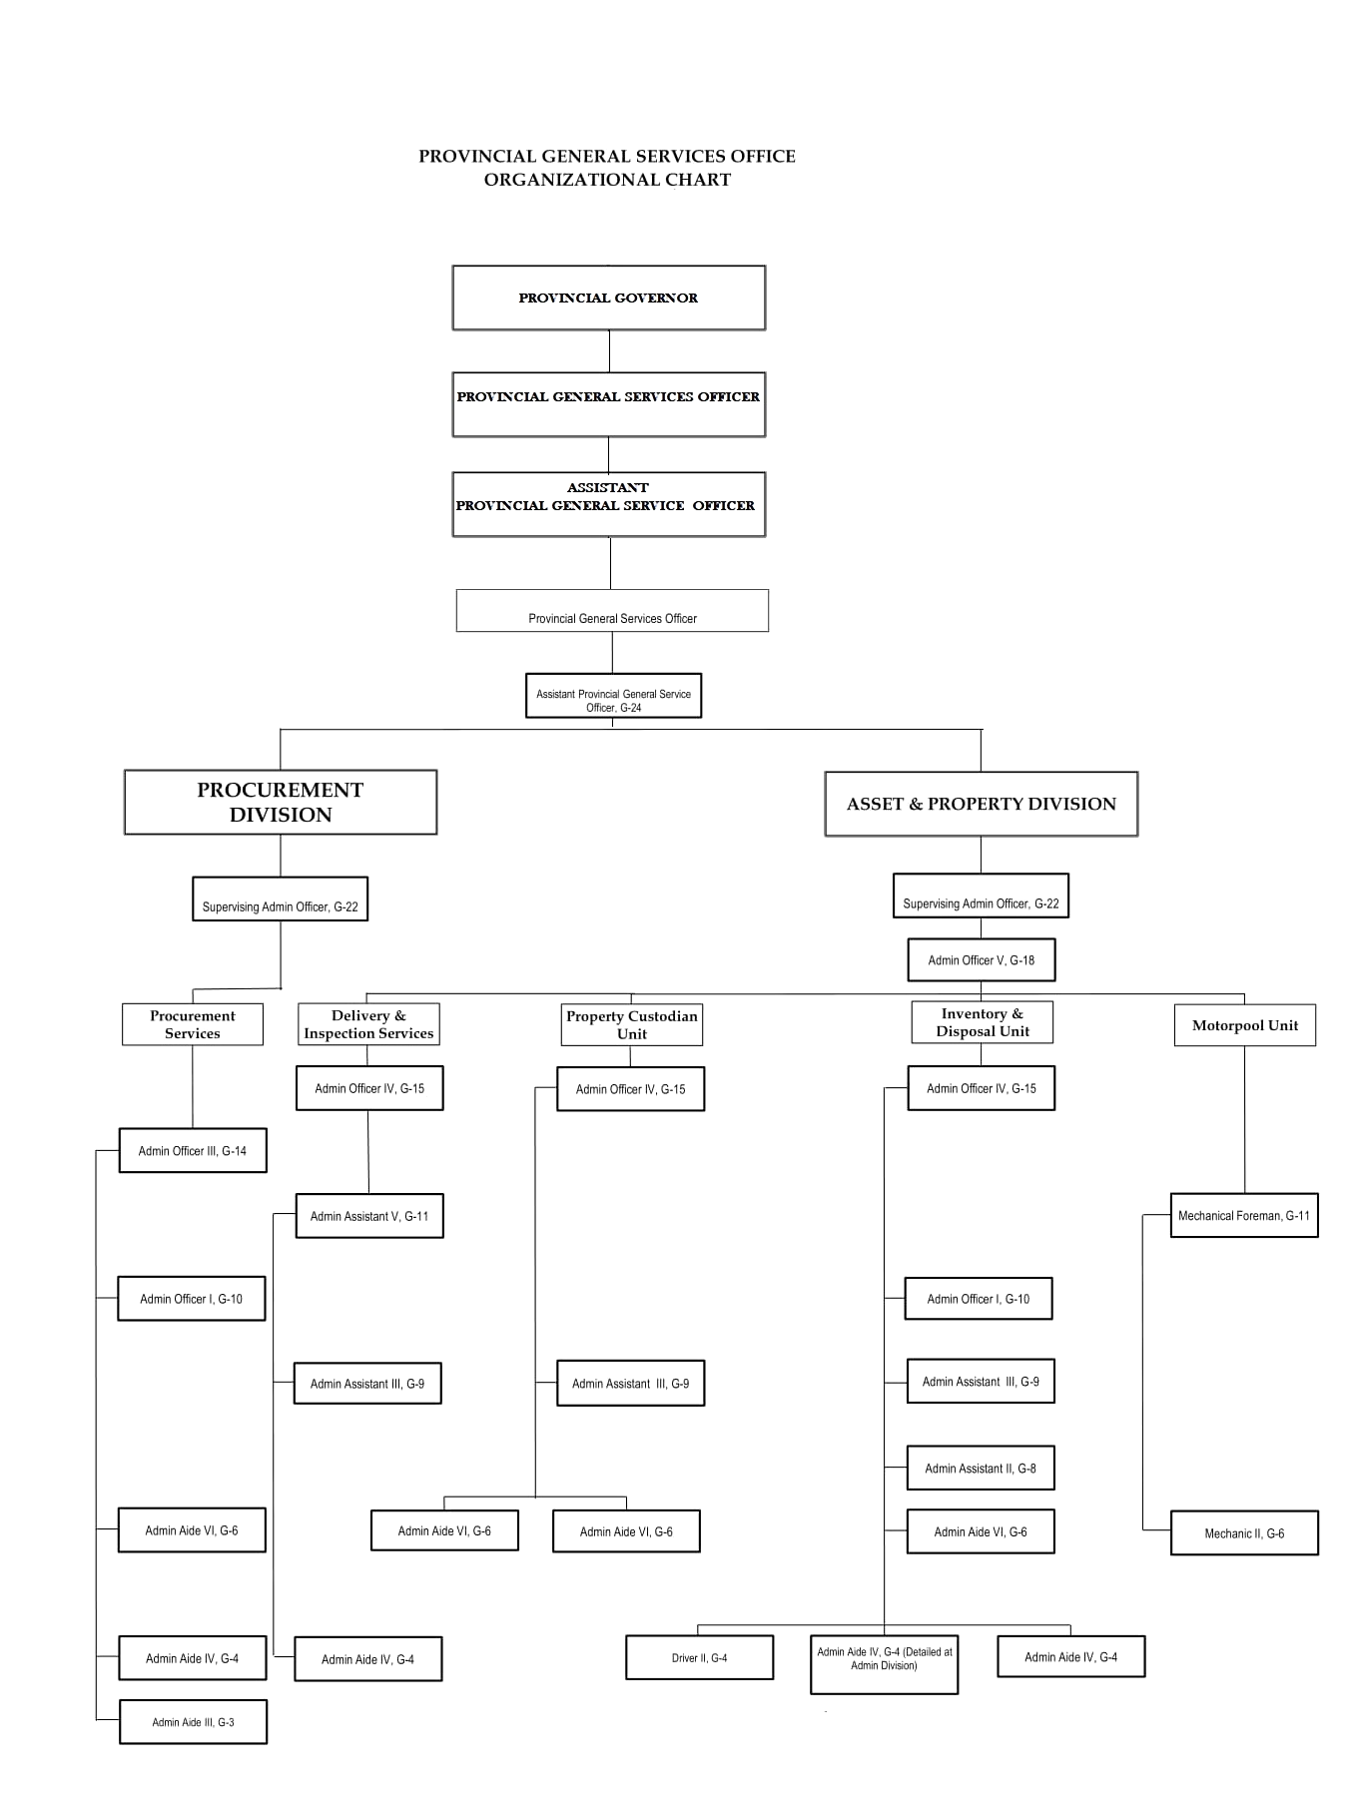

*Figure 1. Organizational Chart of Warehouse General Services Office*

### **Office Operations**

The warehouse office operation involves inventory management and returns. The stocks need to be tracked to ensure that supplies are available for the next transactions and track the overall inventory status of the warehouse office. There are two kinds of returns in the office, the purchase return and product return.

### **Products**

There are 400 to 500 products in the warehouse and divided into five categories, the common office supplies, printer and photocopier consumables, janitorial supplies, office supplies with Inventory Custodian Slip (ICS) and lastly, office supplies with Inventory Custodian Slip (ICS) as per PPSAS-from PAR to ICS/ C.O. to M.O.O.E. Common office supplies do not have waste materials such as coupon bond and ball pen. Second category is the ink and photo copier consumables which have expiration date like inks and toner. Janitorial supplies are the third category which is for cleaning materials. For the the fourth category which is the semi-expendable office supplies with Inventory Custodian Slip (ICS), it has waste materials such as stapler and puncher. Some products have its own reorder point to monitor their stock supplies. The table 1 below shows item examples of each of the category.

|  |  |  |  |  |
| --- | --- | --- | --- | --- |
| **CATEGORY 1(Common office supplies)** | **CATEGORY**  **2(Ink and Photocopier consumables)** | **CATEGORY 3(Janitorial Supplies)** | **CATEGORY 4(Common office supplies with ICS)** | **CATEGORY 5(Office supplies with ICS as per PPSAS -from PAR to ICS/ C.O. to M.O.O.E.)** |
| Alcohol,70% ethyl, 500 ml | Ink Cartridge,Brother LC67, Black | Bag,garbage, 15 x 15 x 37, assorted colors | Album,DVD/CD case,folder | PRINTER, P15,000 & below, EPSON L-360 |
| Bag,paper, brown,#10, 100 pcs/pack | Ribbon,Epson SO15632 | Brush,plastic long handle | Box,file data, 4 drawers,plastic | PRINTER, P15,000 & below, EPSON L-365 |
| Bag,zip, XXL, 20pcs/pack | Ink Cartridge,Canon PG-830 | Cleaner,glass,with sprayer, 500 ml | Calculator,scientific | SEAL, DRY |
| Ballpoint pen,BPS,fine, (blue,black,red for hospitals only) | Toner cartridge, for fuji xerox S2320 | Conditioner,fabric, 1 gallon | Card Reader, Internal | UPS, P15,000, UPS, 1500VA |
| Battery,alkaline, size AAA | Ink cartridge,for HP Officejet 7110, original, (4 cart/set-complete colors | Detergent powder, 1000g, (not from DBM | Flash drive,USB, 32 GB | Network Printer and storage, usb type, usb 2.0 port mfp |
| Binder,plastic,spiral, black,19 mm x 1.2 m (3/4x44") | Ink Cartridge,HP No. 60, Combo Pack (Black & Tri-color) | Disinfectant,500 ml | Hard Disk Drive,external,USB,1 TB | Rechargeable Battery w/ charger {Energizer with 2 AA pcs of battery) |
| Blade,cutter,L500, 10's/pack | Ink Cartridge,HP No. 920 XL, Black | Doormat,cloth, 20" x 15" | Numbering Machine,automatic | Rechargeable Battery w/ charger {Energizer with 2 AAA pcs of battery) |
| Board,specialty, long,10s/pack | Ink Cartridge,HP No. 94 | Freshener,air, 320 ml | Stamp,numbering, 12 digits | Telefax machine, EPSON L-565 |
| Book,record, wide,official,500 leaves | Ink Cartridge,HP Officejet J4660, 901, Black, Hitam | Insecticide,multi-insect killer, 420 g/can | Stapler,heavy duty,w/ wire remover | Recorder, voice, digital, Sony ICD-PX 440 |
| CD-Rewritable,with case | Toner,Develop TN 511, for INEO 500 | Mophead,all cotton, twisted,400 grams | Epson-L360, Printer | Table, office table |
| Diskette,3.5 (Formatted IBM- Verbatim) | Print Cartridge,Docu Print C3290 FS, magenta | Pad,scouring,with foam,economy size | Supplies with ICS  (Dry Seal | Table, computer table |
| Paper Cutter, heavy dutym metal, steel base, 12"x15" | Toner, HP 128A CE 320A, P1566, P1606 | Furniture cleaner, 330ml | Rechargeable Battery w/ Charger-Energizer with 2 AA Battery |  |

*Table 1. Example of Items*

### **1.2.2.1.1 Procurement Issuance Process**

Figure 2 shows an overview of the procurement issuance process where each department must submit their estimated individual Project Procurement Plan (PPMP) for the whole year and is divided into two quarters. Project Procurement Plan (PPMP) will be submitted to the General Services Office (GSO) Warehouse and to the involved offices for approval.

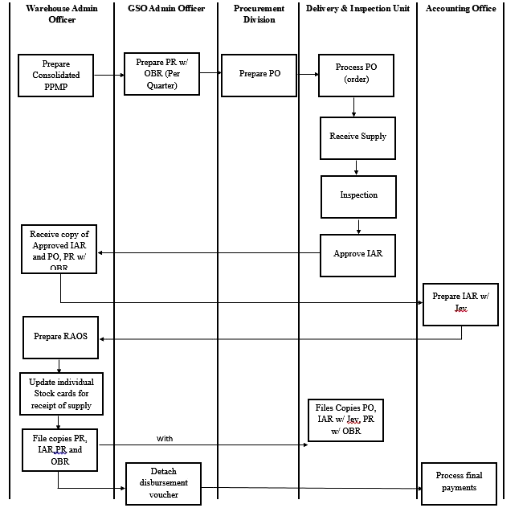

*Figure 2. Workflow Diagram for Procurement Issuance Process*

### **1.2.2.1.2 Product Issuance Process of common office supplies, printer and photocopier consumables and janitorial supplies.**

The products category one, two and three are being issued by the General Services Office (GSO) warehouse. These categories do not require an Inventory Custodian Slip (ICS). The products will be issued by the General Services Office (GSO) Warehouse upon the request of the end user with the Requisition and Issue Slip (RIS) and Supplies Availability Inquiry (SAI) made by Accounting Office. The Accounting Office will check the stock number and Project Procurement Management Plan (PPMP) with Supplies Availability Inquiry (SAI) of the end user who requested an item. To further illustrate the product issuance process, refer to Figure 3.

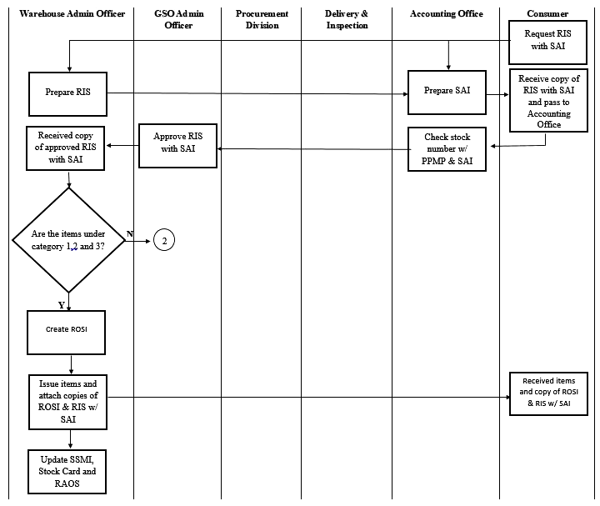

*Figure 3. Workflow Diagram for Product Issuance Process of Category One, Two and Three*

### **1.2.2.1.3 Product Issuance Process of office supplies with Inventory Custodian Slip (ICS)**

Figure 3 shows how category four and five are being issued by the General Services Office (GSO) warehouse. The issuance process of category four and five is the same as the issuance of categories one, two, and three. The only difference is that these categories have the form Inventory Custodian Slip (ICS).

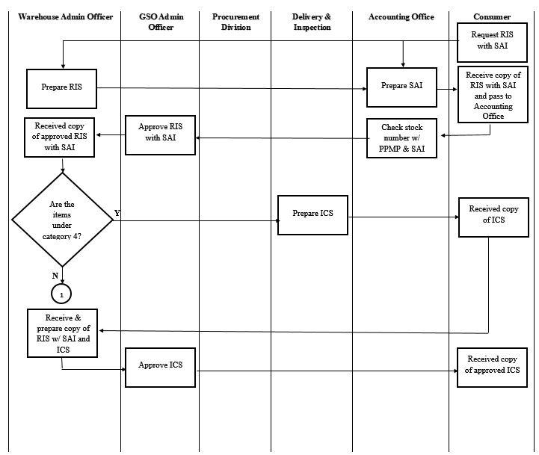

*Figure 4. Workflow Diagram for Product Issuance Process of Category Four and Five*

### **1.2.2.2 Product Delivery Process**

The Delivery and Inspection Units will receive the products and check if the delivered products are complete using the Purchase Order (PO) records. When the delivered products do not meet the demands of the General Services Office (GSO), the inventory and inspection unit will inform the supplier regarding the products that have been delivered to the warehouse**.**

### **1.2.2.3 Returns**

There are two types of returns in the General Services Office (GSO). First is the purchase returns, where if the purchased items are about to expire in less than a year, the warehouse will return the items to the supplier regarding the agreement between General Services Office (GSO) and supplier. Second is the product returns, where if the consumer made a mistake in claiming the wrong item, it should be returned to the warehouse and it will be exchanged to the correct requested items.

### **1.2.2.3.1 Purchase Returns to Supplier**

Figure 5 shows the products returned to the suppliers which are called purchase returns. Products under the Printer and Photocopier Consumables that are about to expire in less than a year is needed to be returned to the supplier which is on the agreement of the General Services Office (GSO) and the supplier. The warehouse will return the items if the supplier has delivered the wrong items and will replace it based on the specified purchase order record. If it is the fault of the consumer, the warehouse will cancel or compromise with the supplier regarding the needs, suggestions, and recommendations of the consumers then the supplier will change the item that has been delivered.  Defective products are returned after the inspection of the items done by the Delivery and Inspection Unit. To further illustrate the purchase returns to supplier process, refer to Figure 5.

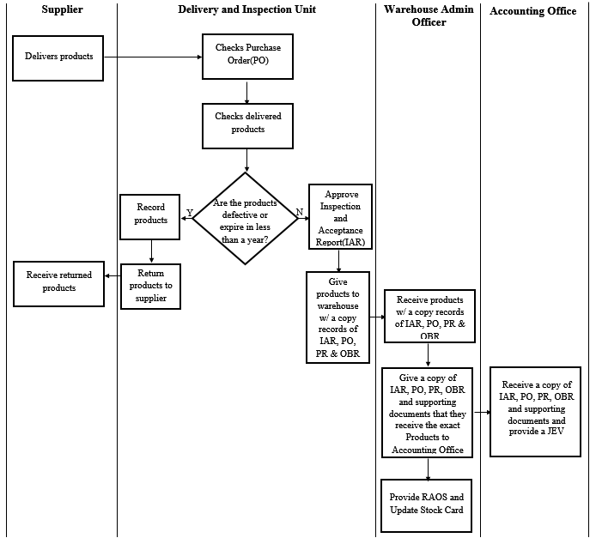

*Figure 5. Workflow Diagram for Purchase Returns*

### **1.2.2.3.2 Purchase Returns to Warehouse**

Products are returned due to the mistake of the warehouse personnel whenever they deliver the wrong product and when the consumers claimed the wrong item from the warehouse. The process of product returns to the warehouse is shown in Figure 6.

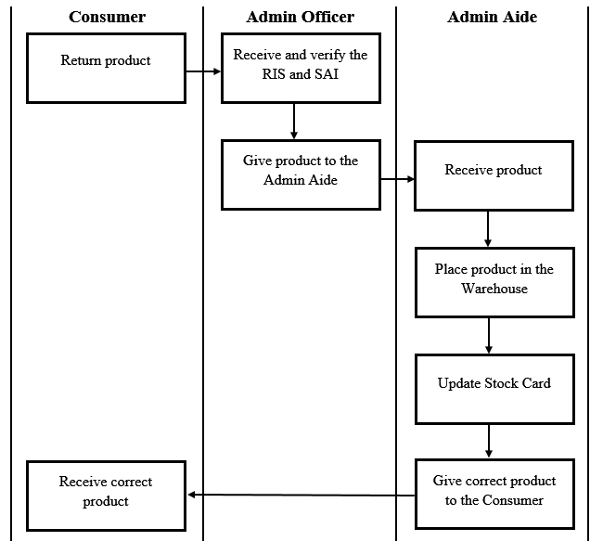

*Figure 6. Workflow Diagram for Product Returns*

### **1.2.3 IT Infrastructure**

As shown below in Table 2, there are four computer units in their office that has an internet access. Those units are supposed to be kept for encoding records like the purchase request, project procurement management plan, obligation request, purchase order and stock cards. The warehouse records their transactions with the use of an excel spreadsheet. The computers in the Warehouse office are greater than the minimum required for the system to work. Table 2 shows the specifications of the computers.

|  |  |  |  |  |
| --- | --- | --- | --- | --- |
| **Minimum Specifications** | **Desktop A** | **Desktop B** | **Desktop C** | **Desktop D** |
| **Independent Operating System** | **Windows 7** **professional** | **Windows Home 10** | **Windows Home 10** | **Windows 7** |
| **1mb Cache, 1.90 GHz** | **Intel Core i3 2.4 GHz** | **Intel i5** **3.0 GHz** | **Intel Core i5** **3.0GHz** | **Intel Core i3** **2.4 GHz** |
| **1 GB RAM** | **4GB DDR3** | **8GB DDR3** | **4GB DDR4** | **4GB DDR3** |

*Table 2. Computer Specifications*

### **1.2.4 Problems Encountered**

The warehouse deals with many requests like the request form issued to the different departments per day and every request is recorded in a paper. Each request form is kept in a filing cabinet and whenever the personnel will encounter sudden problems like having miscalculation of items, the personnel will still have to find the forms from the cabinet and resolve the problem. It would take time for the warehouse personnel to look and find for a specific record considering they have lots of record stored and kept in the filing cabinet since there are only four warehouse personnel that facilitates the warehouse. The problems of the office are:

1. Difficulties in maintaining and updating spreadsheets because of the big data that they have.
2. Monitoring supplies that are about to expire where items are under the category two are the items that has an expiration date.
3. Issuance of items - the admin has no summarized record of the personnel who issued and received the items.
4. Nonconsecutive stock number of items - the stock number of the items are not in order which causes problems for the warehouse personnel.
5. Pick up and delivering the wrong items - There are times where consumers pick up the wrong items and the warehouse personnel deliver the wrong items to the consumers.
6. The warehouse personnel lost records due to lack of update of the stock cards.

In order to solve the problems encountered, the developers proposed an Inventory Management System to the Warehouse of General Services Office (GSO). This will let the employees to work efficiently, have access to accurate data, reduce the volume of the paper works, and produces structured reports.

## **1.3 Statement of the Objective**

The general objective of the project is to develop an inventory system for the General Services Office Warehouse Unit of the Benguet Provincial Capitol. The goals to be accomplished in order to complete the study are the following:

1. To gather and understand the requirements of the current system, both functional and nonfunctional, which will be the basis for the design and development of the proposed system.
2. To create a design using design models as a basis for the systems implementation.
3. To implement the features and modules of the system based on the requirements gathered.
4. To deploy the system according to the requirements and needs of the company.

## **1.4 Scope of the Project**

The project covers the requirement elicitation, planning, modeling, implementation and testing of Warehouse General Services Office System to be able to reach the objectives of the company. The team will undergo with the following activities:

1. Requirements elicitation will consist of interviews and observations to fully understand the business operations and determine the requirements of the company.
2. Planning will involve the time of meetings with the client and the group for validation purposes of the proposed system.
3. Modeling will cover the illustration of the design of the system using diagrams and models.
4. Implementation and testing will involve the selected tools during the development of the system and cover walk-through testing of the system.

## **1.5 Significance of the study**

This study will be able to show a web-based inventory system for General Services Office of the Benguet Provincial Government for minimizing the time consumed by the warehouse personnel during office operations. The monitoring of records is easier especially when the supply records will be kept in a web-based inventory system. The company will be able to maintain the records in an orderly manner and have accurate information about the stocks availability of an item. For the future developers this documentation will guide the next generation of IT developers to fulfill their duties and responsibilities of developing a unique web-based warehouse inventory management system.

# **CHAPTER 2**

# **METHODOLOGY**

The Iterative lifecycle model does not start right away with a full specification. It is divided into smaller types that came from what the developers have produced throughout the cycle. Each of these subsequent release of the module adds functionality to the previous system. The developers will go on with the operation until all the business requirements are finished. This draws the developers to control the changes from the demand of the clients and solve errors or features easily. This will allow the developers to be included in the designing of the first piece of the system then followed by the latter pieces. Each piece will undergo multiple stages mainly the requirements, design, testing and implementation allowing the developers to meet the ongoing changes to the requirements of the system. The developers chose the Iterative Model for the system development because it is easier to develop and test when iterations are broken down into smaller types and customers can give their feedback quickly making it convenient for them for they can just simply evaluate and see the progress in the system. The model also has the ability to modify the dynamic needs both of the project and the desires of the client.

## **2.1 Requirements Analysis**

The developers will come up with a set of requirements for the project. This will include the following phases: feasibility study, requirements elicitation, requirements specification, and requirements validation.

The feasibility of the study was performed by conducting several brainstorming sessions with government representatives and group members.

Requirements elicitation was performed by conducting interviews. The group interviewed the Admin officer together with the head of the IT department. The developers also had an observation operation of the warehouse for six hours and conducted the analysis of forms. The forms which were analyzed includes Inventory Custodian Slip (ICS), Inspection and Acceptance report, and Purchase Order. The developers used a high fidelity prototype in the form of a Balsamiq mockup in the elicitation of requirements.

The developers created an outline of the requirements as a group and classified them as a functional or non-functional requirements for the requirements analysis. The developers also validated the requirements by conducting informal walkthroughs of the different requirements.

## **2.2 Functional and Non-Functional Requirements**

The development of the system is based on the functional and non-functional requirements. These two requirements will be the foundation of how the system will work when used by the employees. In knowing these requirements, the developers used the basic type of data gathering techniques. The developers did the gathering of information by interviewing the employees and the end-users, and observe how both parties interact when a transaction occurs. These are used in identifying the requirements needed for the system.

### **2.1.1 Interviews**

The developers interviewed the warehouse admin officer regarding the warehouse processes together with those who are involved in the department in handling the inventory system. This includes the interviews and document analysis resulting in the development of the system. The developers conducted an interview with the admin head of the warehouse at the General Services Office to fully understand the business process including the offices or departments involved. The developers asked for the forms used in the current process to help in determining the attributes to be used. Follow-up interviews with the head of the warehouse were done whenever clarifications and additional information regarding the inventory process were needed. Data gathered will be used in determining the functional and nonfunctional of the system according to the needs and requirements of the end user.

### **2.1.2 Document Analysis**

The developers requested for forms that are being used for their transactions such as logbooks, purchase orders, purchase request, and receipts that are being used in the agency’s operations. The developers used these forms to understand and have a view of their inventory system like how each process were done and how they monitor, update, and maintain the inventory records. The gathered information from these documents were then used in designing of the interface of the system and its functionalities.

## **2.3 System Design and Implementation**

The system design, development, testing and evaluation phases will be implemented. These phases will help the developers to understand the system during development. It will also help them to know the requirements of the system and the tools that will be used to create the mock ups, front-end and back-end.

### **2.3.1 Design**

The system design was where the architecture of the system is defined including the modules, interfaces, and data of the system for the satisfaction of the specific requirements. In order for the developers to model the system, the Data Flow Diagram (DFD) is used for the representation of the flow of data in the Warehouse unit of the General Services Office (GSO). It will represent the process through the information system while the Use Case Diagram is used for describing the actions of how the system will perform to collaborate with the user. The making of the Mockups for the UI design is for the developers to create the user interface as to how the system will look when it is already implemented. This will be the basis for the application layout in order for it to be user friendly.

### **2.3.2 Determining Data Architecture**

The developers chose the data architecture that they used in creating the system. The chosen diagrams were the Data Flow Diagram (DFD), Flow Chart, and Use Case. The Data Flow Diagram helped the user to know the business process of the company. The Flow Chart helped the developers understand the current process of the company and the Use Case has shown the interaction between the user and the system.

### **2.3.3 Designing the Database models and Schema**

Based on defined modules and interfaces, the developers used an Entity-Relationship Diagram (ERD) for determining the relational database where it helped the developers in determining the entities and the relationship between people, objects, and concepts of the system.

### **2.3.4 Designing the User Interface**

After the developers have determined the requirements, the gathered information were analyzed to come up with the modules and features of the system. With the help of the Use case diagram, the developers easily specify the actions and process between the user and the system.

## **2.4 Development Architecture**

The developers created mock-ups of the system. The developers checked if the mock-ups of each module contains the specified requirement that was given by the office manager. After the testing of the system, the developers let the office manager check the mock-ups for them to know their feedback. The changes that were made were based on the feedback given by the office manager. If the office manager is satisfied, the developers will proceed to the next module, check the specified requirements, test the mock-ups, and let the office manager check it again. If the client is not satisfied, the developers will revise it and apply the changes. The process will continue until the last module has been made.

### **2.4.1 Front End Development**

The front end development of the system started on selecting which tools were to be used. Wide variety of tools and technologies were available for use in the making of the User Interface. The mockups that were created were the basis in creating the Interface. The steps to be followed in making the front-end were based on the experience of the previous projects made by the developers. These are needed in order for the developers to begin creating the Interfaces.

### **2.4.2 Back End Development**

The back end was made in sync with the front end development. Same tools were used in creating both the front end and back end. With the development of the back end, databases were also created and populated. The data used in populating the database were from the current data and documents that the company has provided to the developers.

## **2.5 Testing the system**

The testing phase let the developers saw the performance or the behavior of the system when there’s an interaction between the users. There were other testings that were done in which developers saw the quality and functionality of the system. These were observations if the right data appeared upon using all the functionalities of the system. Each tester tried different inputs or approach to the system to check if no errors appeared. The results of the different approach that were used will be evaluated by the developers.

## **2.6 Evaluation**

After the testing of the system, the developers let the Company Personnel evaluated the system to see if it their expectations and the requirements were met which they have given to the developers. Each employee had their opinion about the system and it was recorded in order for the developers to know how to improve the system.

## **2.7 Deploying the System**

For the system to be deployed, there were issues that must be checked such as the hardware and software compatibility. The company has no problem with the hardware and software since all the hardware contain high specifications and the software are compatible with the programs that will be installed in order for the system to work.

# **CHAPTER 3**

# **OUTCOMES AND RESULTS**

The outcomes and results is based from the results of the previous chapter which is the methodology. This contains both the functional and nonfunctional requirements which served as the basis for the features and modules of the system and the results of the steps that were followed in implementing the system.

## **3.1 Functional and Nonfunctional Requirements**

With the method of interviews, observation, and analysis, the functional and nonfunctional requirements were determined.

### **3.1.1 Functional Requirements**

The functional requirements refer to the main functionalities that are available in the system. The functional requirements for the system are indicated in Table 3.

|  |  |
| --- | --- |
| **Functional Requirements** | **Description** |
| User Authentication | The system must enable the users to login to access the inventory system and logout from the system. |
| Change Password | Users must be able to change password for security purposes. |
| Inventory Management | The system must allow authorized users to manage the inventory, view item details, add items, add quantity of items, remove items, count number of items, and edit the details of items. |
| Generate Reports | The system must provide a report to be able to track items in the inventory. |
| Transaction Management | All inventory management transactions must be recorded by the system to track changes of items. |
| User Management | Authorized users must be able to add, delete, edit and view user accounts. |

*Table 3. Functional Requirements*

### **3.1.2 Non-functional Requirements**

The non-functional requirements of the system as presented in Table 4, involves the operational security and performance requirements. The present system must perform the following criteria.

|  |  |
| --- | --- |
| **Non-Functional Requirements** | Description |
| Security | The system must be only accessed by authorized users and defend itself from the threats that can attack the system. |
| Performance | The system must be able to perform all the transactions faster than the current amount of time that they spend. |
| Availability | The system must be available to the employees at any time. |
| Scalability | The system must handle the data which are growing in every transaction. |
| Traceability | The system can track who were involved in the transactions. |

*Table 4. Non-functional Requirements*

## **3.2 Modules and Features**

Each module has its own privileges regarding each of the requests of the offices. These are based from the functional and nonfunctional requirements that was gathered by the developers during the interview that they conducted. Additional features are added together with the request of the users.

### **3.2.1 User Module**

The main features of the user module are mostly for the issuance of items for all the offices. All requests per day exceeds more than a hundred from the twenty-two offices. The user module is used by the employees with some of the OJT students that are assigned to the warehouse office.

|  |  |
| --- | --- |
| **Feature** | **Description** |
| Item  Issuance | The requests of the offices are accepted. All transactions are recorded and stored in the database which will be viewed and checked by the admin. |
| Item Issuance Management | The user will be able to edit the transaction details like removing or updating the transactions since the users are not always aware of the problem like the lack of information about the different transactions. |
| Item Returns | The user will be able to accept the item returns regarding the wrong items that was claimed, unusable items for that specific department, and items that are not used in their office. |

*Table 5. User Module Features*

### **3.2.2 Admin Module**

The admin module has all the access of the system that includes editing, adding, updating, and deleting of items. The admin module can manage the user accounts such as creating, updating, and deleting of new accounts. The admin module will generate reports that are sent to each of the offices of the Provincial Capital.

|  |  |
| --- | --- |
| **Feature** | **Description** |
| Account Management | The admin has the right to update, delete the user accounts, and  add new accounts for new users. |
| Item  Management | The admin can alter the information of the items in the inventory system such as adding, updating, and deleting of items. |
| Supplier Management | The admin will be able to update and delete current information of the supplier such as the company name, address, and contact information. The admin can add new suppliers for the new item that was added or change the suppliers of old items. |
| Reports Management | The admin will be able to generate the reports to each of the offices in the Provincial Capitol. The requests are the Project Procurement Management Plan (PPMP), RAOS, Summary of Supplies and Materials Issued (SSMI), and Stock Cards. |
| Logs  Managements | The admin can see the logs where the employees have issued the items and users who logged in the system. The admin can review and check if there were any errors from the transactions of the employees. |

*Table 6. Admin Module Features*

## **3.3 Design of the System**

In order for the developers to create and design the system, diagrams were used to fully understand the system requirements. The diagrams will let the developers to understand how the system interact with each transaction in relation with the system users.

### **3.3.1 Relational Database Scheme**

ACCOUNTS (accountID, firstName, lastName, username, password, userType)  
 AK username  
CATEGORY (categoryNo, categoryName)  
 AK categoryName  
HISTORY (historyID, logID, accountID, historyDescription, itemDescription, itemQtyIssued)  
 FK logID REFERENCES LOG  
 Update Restrict Delete Restrict  
 FK accountID REFERENCES LOG  
 Update Restrict Delete Restrict  
 FK itemDescription REFERENCES INVENTORY  
 Update Restrict Delete Restrict  
INVENTORY (inventoryID,  itemID, poID, categoryName, unitType, itemDescription, totalQuantity, reorderLevel)  
 FK itemID REFERENCES ITEM  
 Update Restrict Delete Restrict  
 FK unitType REFERENCES ITEM  
 Update Restrict Delete Restrict  
 FK itemDescription REFERENCES ITEM  
 Update Cascade Delete Restrict  
 FK categoryName REFERENCES ITEM  
 Update Restrict Delete Restrict  
 FK poID REFERENCES PO  
 Update Cascade Delete Restrict  
ISSUANCE ( issuanceID, officeID, itemID, issuerName, issueDate)  
 FK officeID REFERENCES OFFICE  
 Update Restrict Delete Restrict  
 FK itemID REFERENCES ITEM  
 Update Restrict Delete Restrict  
ITEM (itemID, stockNo, categoryName, unitType, itemDescription, brand, expirationDate, supplierName)  
 AK itemDescription  
 FK categoryName REFERENCES CATEGORY  
 Update Restrict Delete Restrict  
 FK supplierName REFERENCES SUPPLIER  
 Update Cascade Delete Cascade  
 FK unitType REFERENCES UNIT  
 Update Cascade Delete Cascade  
LOG (logID, accountID, time-in, time-out, date)  
 FK accountID REFERENCES ACCOUNT   
OFFICE (officeID, officeName, fppCode, rcCode)  
 AK officeName  
PPMP (ppmpID, officeID, itemDesciption, itemQty, unitPrice, status)  
 FK itemDescription REFERENCES ITEM  
 Update Cascade Delete Restrict   
 FK officeID REFERENCES OFFICE  
 Update Restrict Delete Restrict  
PO (poID, itemID, orderQty, unitPrice, totalUnitPrice, totalAmount, unitType,    
 categoryName, supplierName)  
 FK itemID REFERENCES ITEM  
 Update Restrict Delete Restrict  
 FK unitType REFERENCES ITEM  
 Update Restrict Delete Restrict  
 FK supplierName REFERENCES SUPPLIER  
 Update Cascade Delete Cascade  
 FK categoryName REFERENCES ITEM  
 Update Restrict Delete Restrict  
RETURN (returnID, inventoryID, itemID, categoryName, unitType, itemDescription, returnStatus)  
 FK itemID REFERENCES ITEMS  
 Update Restrict Delete Restrict  
 FK inventoryID REFERENCES INVENTORY  
 Update Restrict Delete Restrict  
SUPPLIER (tinNo, supplierName)  
 AK supplierName  
UNIT (unitID, unitType)  
 AK unitType

### **3.3.2 Entity Relation Diagram**

The Entity Relation Diagram shows the connection of each transaction when the warehouse is operating. This shows the entities of the system and how they are related to each other.

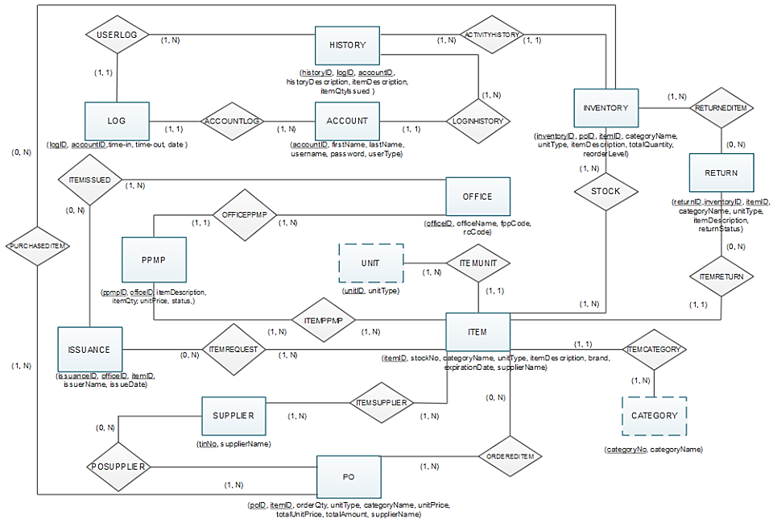

*Figure 7. Entity Relation Diagram*

### **3.3.3 Data Flow Diagram**

The Data Flow Diagram shows the process of how the data will go through the system. It shows what information should be inputted to the system and what corresponding output should be given based on where the data are stored.

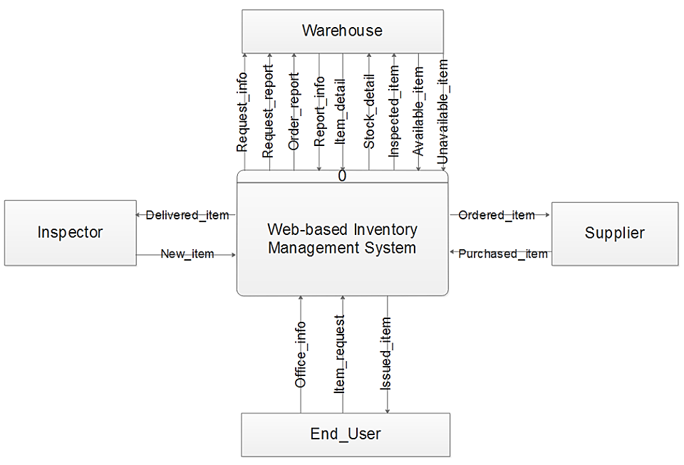

*Figure 8. Context Diagram*

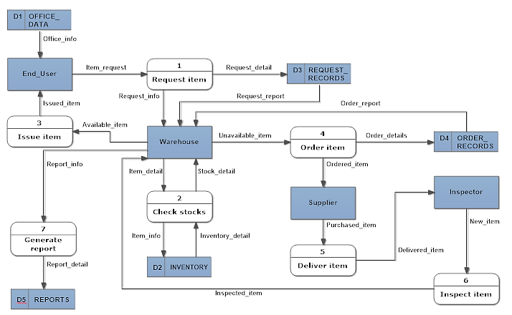

*Figure 9. Data Flow Diagram*

### **3.3.4. Data Dictionary**

The Data Dictionary serves as the list of data used in the data flow diagram.

|  |  |  |
| --- | --- | --- |
| A | | |
| Alphanumeric | = | {A…Z|a…z|,.-|0…9} |
| Available_item | = | {Item_detail + Stock_quantity} |
| D | | |
| Delivered_item | = | {Delivery_number + Purchased_item} |
| E | | |
| End_User | = | {Office_info + User_name} |
| F | | |
| First_name | = | {String} |
| I | | |
| IAR | = | {Alphanumeric} |
| Inspected_item | = | {New_item} |
| Inspector | = | {Inspector_name} |
| Inspector_name | = | {String} |
| Inspected_item | = | {IAR + Delivered_item} |
| INVENTORY | = | {Item_info + Total_quantity} |
| Inventory_detail | = | {Item_code + Item_category + Total_quantity} |
| Issuance_number | = | {Numeric} |
| Issued_item | = | {Issuance_number + Request_info} |
| Item_brand | = | {Alphanumeric} |
| Item_detail | = | {Item_code + Item_category + Item_name + Item_brand} |
| Item_info | = | {Item_info + Item_unit} |
| Item_name | = | {String} |
| Item_quantity | = | {Numeric} |
| Item_request | = | {Item_name + Item_quantity + Item_brand} |
| Item_unit | = | {String} |
| L | | |
| Last_name | = | {String} |
| N | | |
| New_item | = | {Item_detail + Purchased_quantity} |
| Numeric | = | {0-9} |
| O | | |
| OFFICE_DATA | = | {Office_info} |
| Office_info | = | {Office_no + Office_name} |
| Office_name | = | {String} |
| Office_no | = | {Numeric} |
| Order_details | = | {Order_number + Purchased_item} |
| Order_number | = | {Numeric} |
| Order_quantity | = | {Numeric} |
| Ordered_item | = | {Stock_detail + Item_name} |
| ORDER_RECORDS | = | {Orderrecord_number + Order_details} |
| Order_report | = | {Order_details} |
| P | | |
| PO_number | = | {Numeric} |
| Purchased_item | = | {PO_number + Item_name + Order_quantity + Supplier_name} |
| Purchased_quantity | = | {Numeric} |
| R | | |
| Reorder_level | = | {Numeric} |
| REPORTS | = | {Report_number + Report_detail} |
| Report_detail | = | {Report_info} |
| Report_info | = | {Request_report + Order_report + Issued_item + Inspected_item} |
| Report_number | = | {Numeric} |
| Request_detail | = | {Request_number + Item_request} |
| Request_info | = | {End_User + Item_request + RIS + SAI} |
| Request_number | = | {Numeric} |
| REQUEST_RECORDS | = | {Requestrecord_number + Request_detail} |
| Requestrecord_number | = | {Numeric} |
| Request_report | = | {Request_info} |
| RIS | = | {Alphanumeric} |
| S | | |
| SAI | = | {Alphanumeric} |
| Stock_detail | = | {Stock_number + Item_detail + Stock_quantity} |
| Stock_number | = | {Numeric} |
| Stock_quantity | = | {Numeric} |
| String | = | {A-Z…...a-z} |
| Supplier | = | {Tin_No+Supplier_Name} |
| Supplier_Name | = | {String} |
| T | | |
| Tin_no | = | {Numeric} |
| Total_quantity | = | {Numeric} |
| U | | |
| Unavailable_item | = | {Item_details + Stock_quantity + Reorder_level} |
| User_name | = | {First_name + Last_name} |
| W | | |
| WAREHOUSE | = | {INVENTORY + REPORTS} |

*Table 7. Data Dictionary*

### **3.3.5 Use Case Diagram**

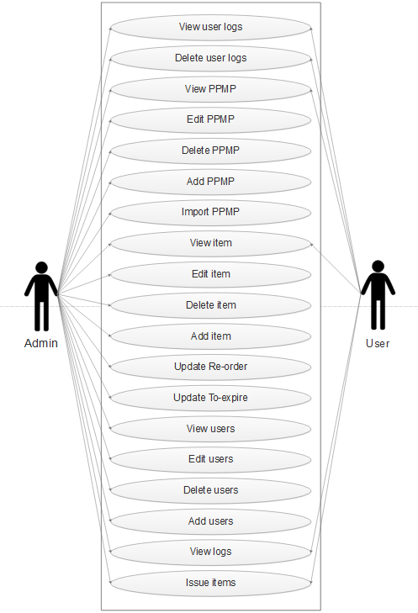

*Figure 10. Use Case Diagram*

## **3.4 Implementation**

Once the designs are completed, the developers will now move on to the next phase which is the implementation of the system. These are the steps to be followed by the developers in order for the system to be implemented.

#### **1. Login and Logout**

The system is able to accept only the users who are authorized to access the system. The users are required to enter their corresponding username and password.

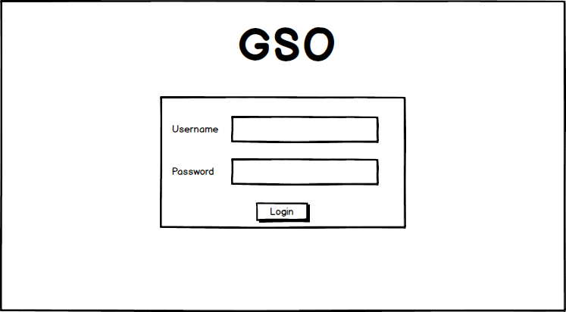

*Figure 11. Login*

#### **2. Importation of Project Procurement Management Plan(PPMP)**

The system is able to add and import the Project Procurement Management Plan (PPMP) in an excel spreadsheet form.

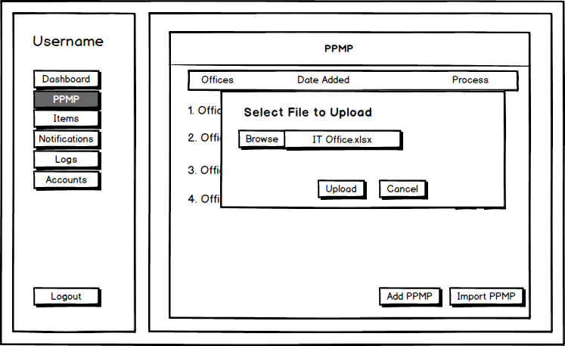

*Figure 12. Importation of Project Procurement Management Plan (PPMP)*

#### **3. Issue Item**

The system will display the issuance form to be filled-up by the users.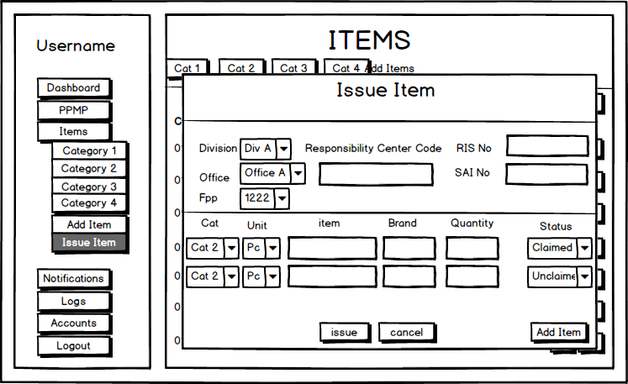

*Figure 13. Issuance of item*

#### **Dashboard**

The dashboard contains the information of the total number of items, items that has to be re-stocked, items that are about to expire, users who has logged in and out who have issued items to the different offices, and the total number of users.

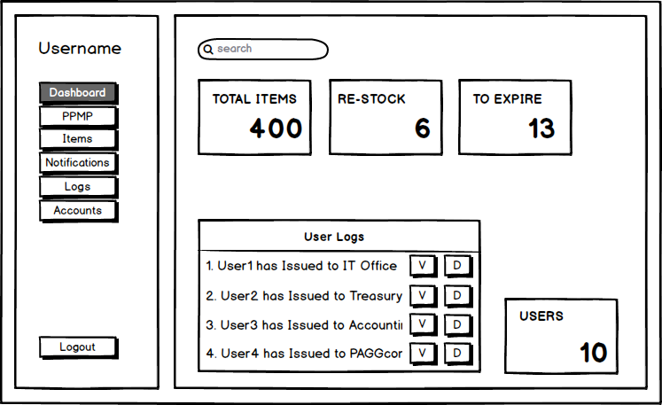

*Figure 14. Dashboard*

#### **5. Reports**

The system displays the different reports of the Project Procurement Management Plan(PPMP), RAOS, Summary of Supplies and Materials Issued (SSMI), and Stock Card that are needed in the transactions. 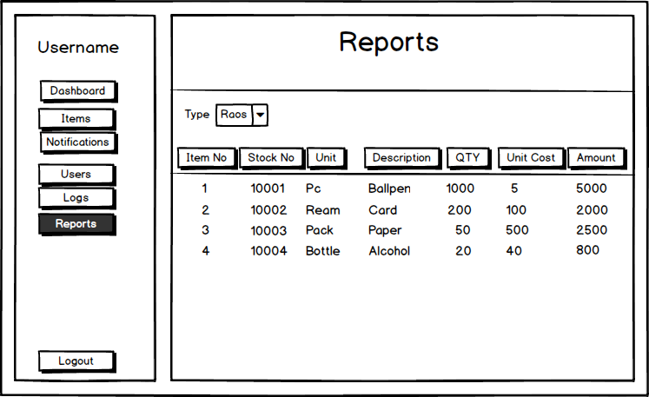

*Figure 15. Generate Reports*

#### **6. Transaction Logs**

The system displays the logs and processes that was made by the user. It allows the user to edit or delete the logs. 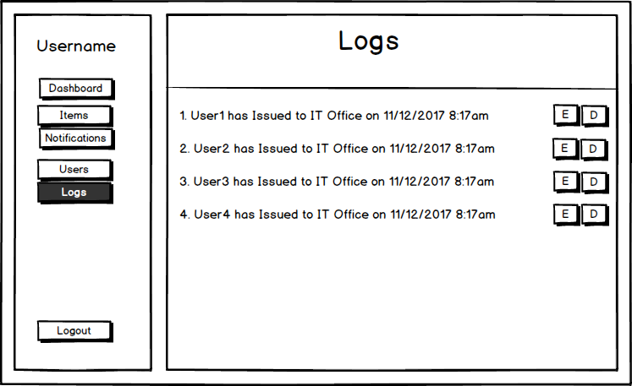

*Figure 16. Transaction Logs*

#### **B. Inventory Management**

##### **1. View Inventory**

The system is able to display the inventory of each category. It allows the user to edit or delete the items in the system.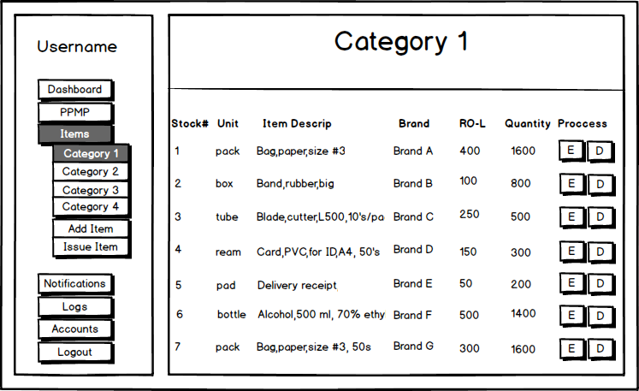

*Figure 17. View Inventory*

##### **2. Edit Inventory**

The system is able to edit and update an item.

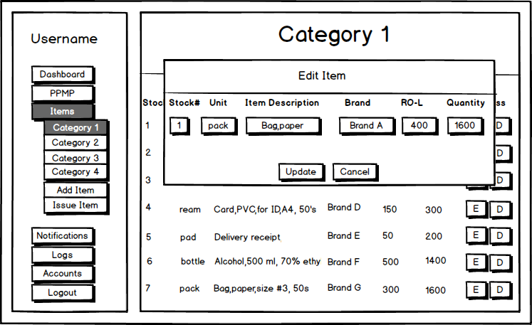

*Figure 18. Edit Inventory*

##### **3. Products to be Reorder**

The system is able to display and process the re-ordering of the items.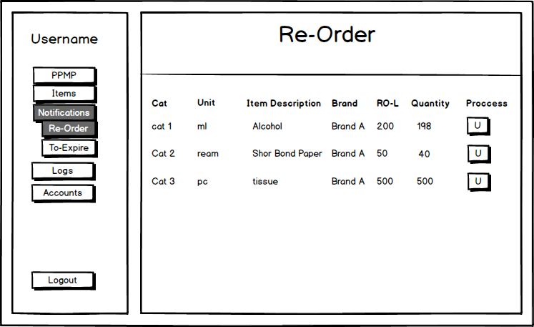

*Figure 19. Re-Order*

##### **4. Products to be expire**

The system is able to display the items which will expire in less than three months.

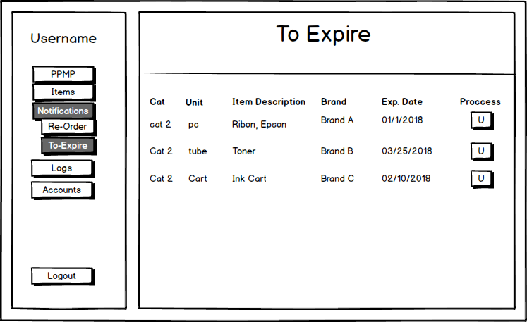

*Figure 20. Products to be expire*

#### **C. Issuance**

##### **1. View Product Issuances**

The system is able to display the issuance form that is to be filled-up by the users.



*Figure 21. View Product Issuance*

##### **2. View Product Issuance Details**

The system is able to display the details of the issuance form that was made by the users.

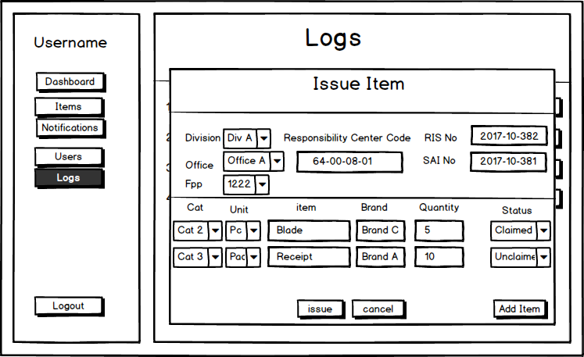

*Figure 22. View Product Issuance*

#### **D. Warehouse Returns**

The system allows the users to see all the items returned to the warehouse.

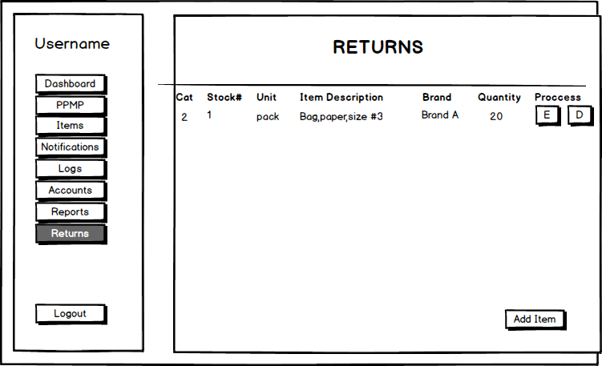

*Figure 23. View Warehouse Returns*

##### **1. View/edit Warehouse Return Details**

The system is able to let the user to view the details about the returned items and can be edited by the user.

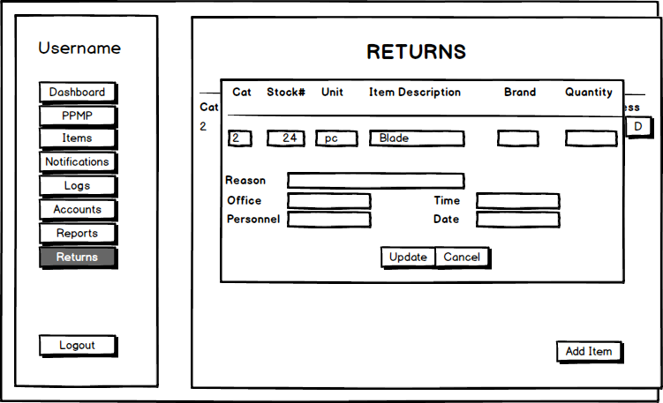

*Figure 24. Edit Returns*

##### **2. Add Product Return**

The system will let the user to add an item that was returned by the offices.

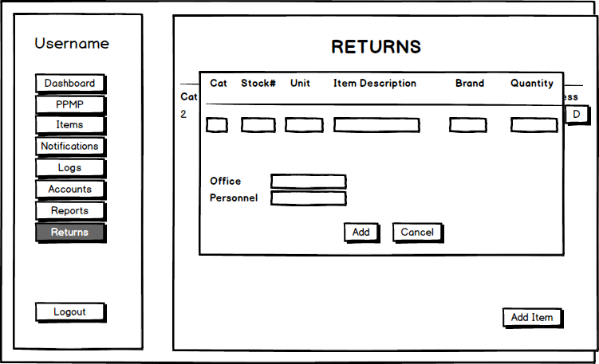

*Figure 25. Add Product Returns*

#### **E. Supplier Management**

The system allows the admin to add, edit, blacklist, and archive supplier profiles that will be used throughout the system. It will manage the suppliers who stops supplying the warehouse and new suppliers that wants to supply the warehouse.

##### **1. View/Edit Supplier**

The system shows all the current suppliers of the General Services Office(GSO) warehouse. The user can edit information about the supplier.

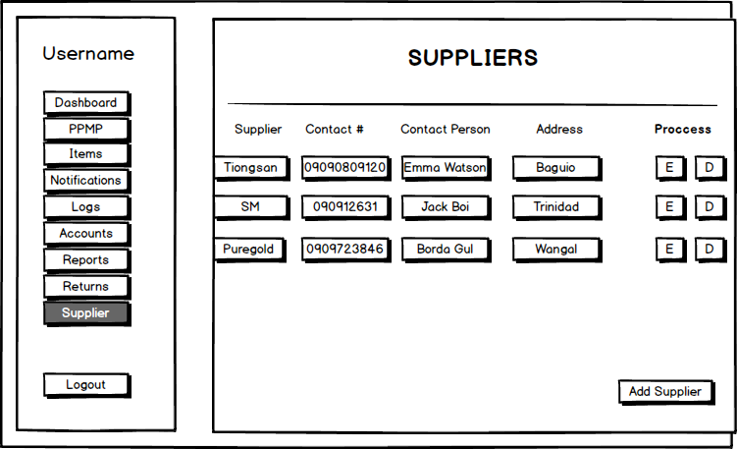

*Figure 26. View and Edit Supplier*

##### **2. Add Supplier**

The system can add a new supplier.

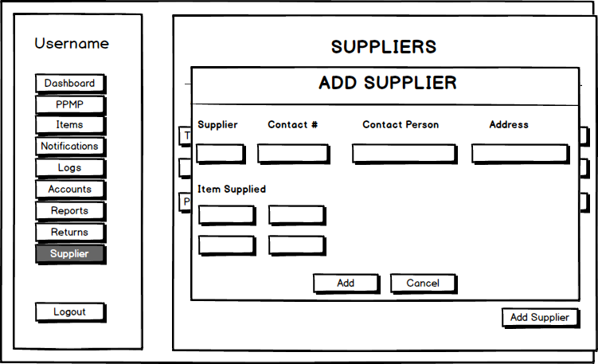

*Figure 27. Add Supplier*

#### **F. Accounts Management**

The admin can manage the different accounts available in the system.

##### **1. View Accounts**

The system displays the list of users and let the admin to edit and delete user accounts.

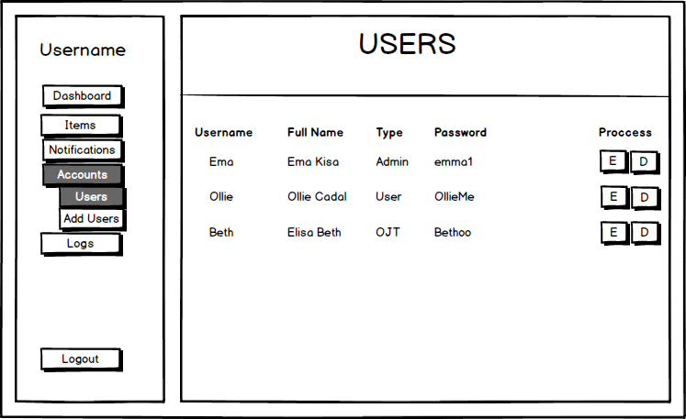

*Figure 28. View Accounts*

##### **2. Edit Current Account**

The system allows the admin to edit and update the credentials of the users.

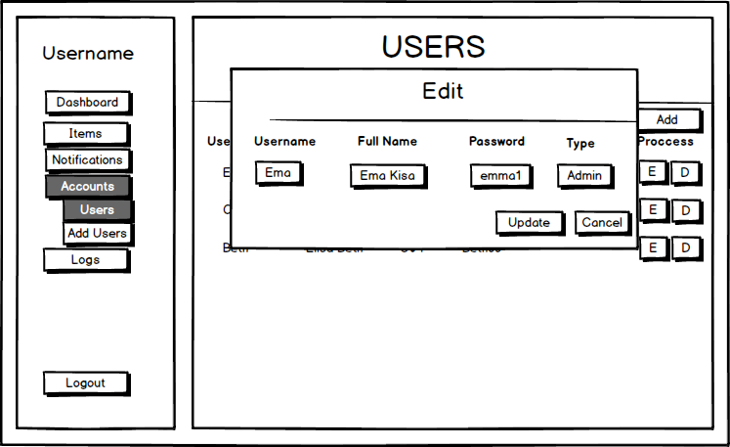

*Figure 29. Edit Accounts*

##### **3. Add Account**

The system is able to add new accounts in case the warehouse personnel decided that a new user should be able to monitor the items and transaction details.

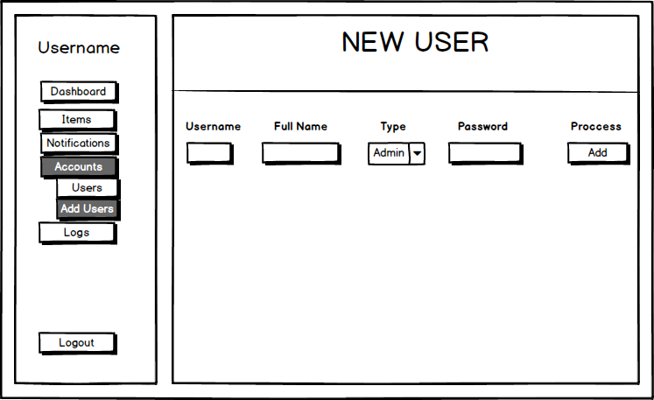

*Figure 30. Add Account*

##### **4. Delete Account**

The system allows the admin to delete the user.

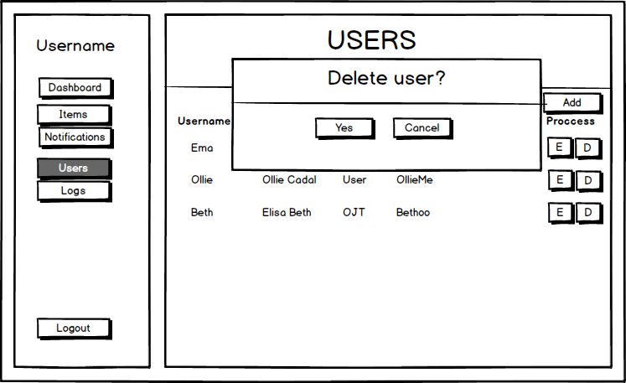

*Figure 31. Delete Account*

### **3.4.1 Tools and Technologies**

Upon the development of the system, several tools and technologies will be used in order to create the system. The tools are text editors and version control tools. The following tables will show the tools and technologies that will be used including the programming language that the developers will use in creating the system.

##### Tools

|  |  |  |
| --- | --- | --- |
| **Category** | **Tool** | **Definition/Usage** |
| IDE Tools | IntelliJ Ultimate | This tool is for the developers to create the code of the system. The text editor of this tool will help the developers in creating simple but organized codes. |

*Table 8. Tools*

##### Technologies

|  |  |  |
| --- | --- | --- |
| Category | Technology | Definition/Usage |
| Programming Languages | Javascript | Javascript will be used in adding functionalities of the system such as sorting of dates and search functions of the system. It will also be used for the form validation in adding of items. |
| HTML 5 | This was used in structuring and presenting the contents of the system. |
| Bootstrap | This will be used for designing the markup that was created using HTML5. |
| PHP | This will be the scripting language for the developers to use in creating the back-end code of the system. It will be used to get and retrieve data from the SQL database. |
| Version Control | Git | A version control for the developers to keep track on all of the changes in the repository. |

*Table 9. Technologies*

### **3.4.2 System Architecture**

The system is a Client-Server architecture as shown below. The system will be configured using the Apache Web Server (WAMP). The application user interfaces an requests are handled by the web server. The warehouse computers of both the admin and employees are the clients of the system. The server will be installed on the administrator's computer where the employees will connect using cables. The database of the system uses MySQL which is an open source database. The database contains all the inventory data that are needed for the system to function.

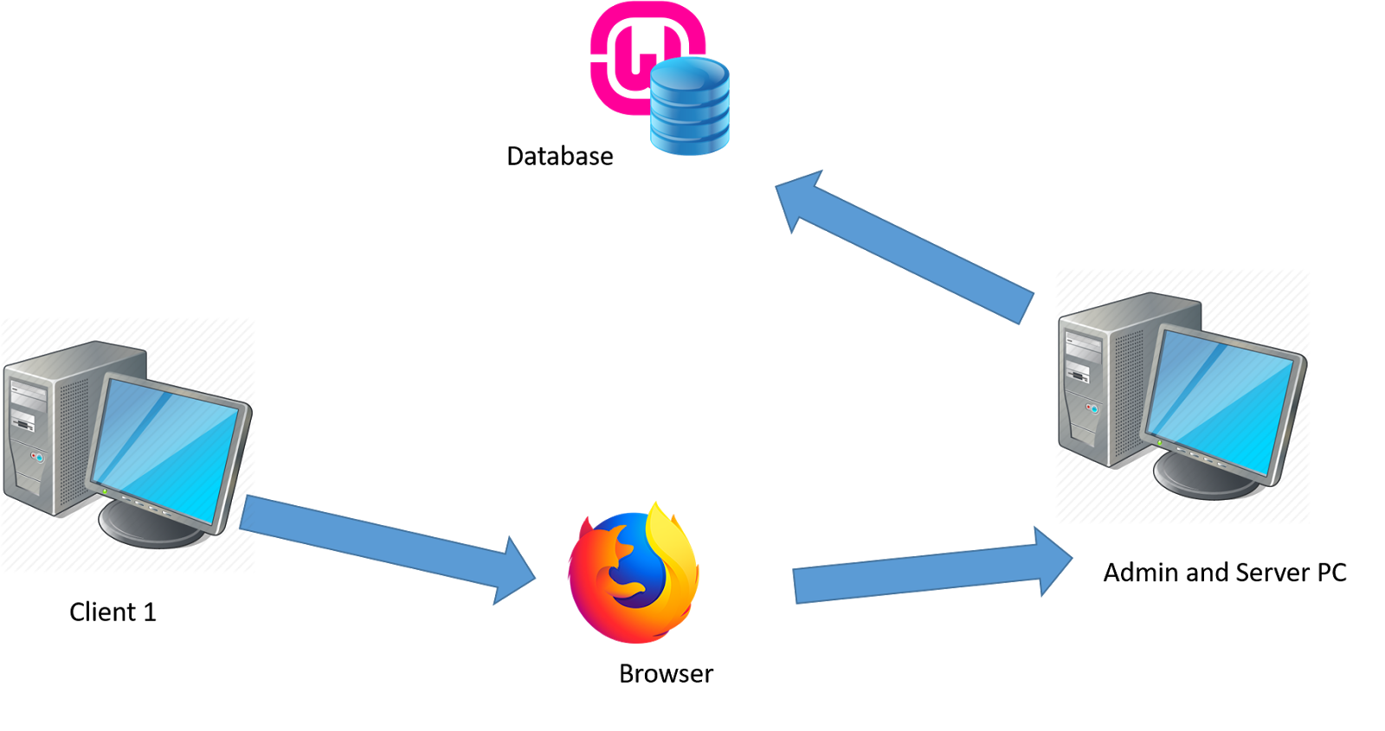

*Figure 32. System Architecture*

### **3.4.3 Layout of the System**

In the set up of the system, the developers will the current layout of the computers in the main office of the company. The layout of the main office is shown in Figure 94. PC1 serves as the client of the system while PC2 serves as the server.

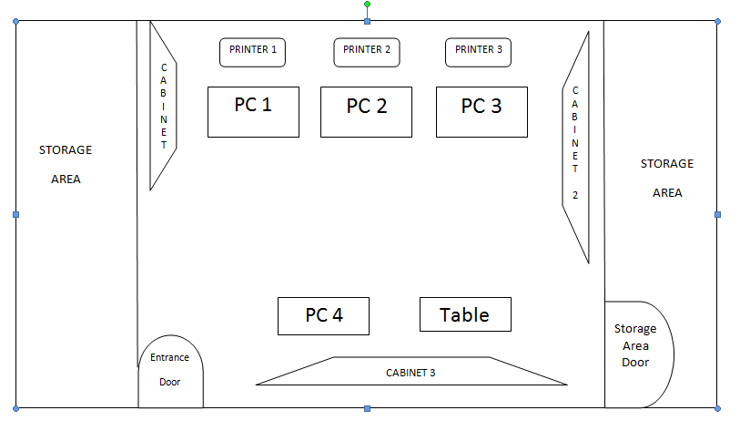

*Figure 33. Layout of the System*

### **3.4.4 Testing**

# **CHAPTER 4**

Chapter 4: Conclusion and Recommendations

A Web Based Inventory System is designed to reduce the redundancy of the information of the items at the General Services Office Warehouse and make the work of the employees easier. The warehouse contains the the supplies that are needed by the different departments. The inventory management system will be able to organize the data that will let the employees to monitor the information of the items easily. The system provide accurate records to manage the information of the items correctly. The inventory system is considered as a consistent system that will be an advantage to the employees because the data that is provided to the employees in an orderly manner that will not lead to confusions.

The developers are required to visit the warehouse to help the employees collect the data in an organized manner. During the development of the project, the developers encountered different issues such as insufficient amount of data where the developers could not start the development right away or at the given time because the employees could not provide the needed data. Changing of adding of requirements are expected in the development of the system but it slows down the production of the group because of the unsure requirements of the employees that are given to the developers and with the unorganized data that they have since the employees only use pen and paper for the recording of their items.

With this conclusion, the developers recommend the use of Incremental method. The Incremental Method allows more room for improvements and revisions that is to be made basing on the clients’ feedback in the iteration of the project. Revisions can be addressed earlier for the developers to have more time in repairing and updating the version of the system.

# **References**

[i] Miles, G. (2017). Top 10 “Must Have” Warehouse Management Systems (WMS) Features. Retrieved from http://www.icepts.com/wp-content/uploads/2011/11/Top-10-Must-Have-Warehouse-Management-Systems-Features.pdf

[ii] Sarkissian, A. (2013). An Introduction to Inventory Systems. Retrieved from <http://yourbusiness.azcentral.com/introduction-inventory-systems-14724.html>

[iii] StudyMode. (2013). Inventory .Retrieved from [http://www.studymode.com/essays/Inventory-1837988.html](http://www.studymode.com/essays/Inventory-1837988.html%5biii)

User, S. (n.d.). Retrieved from <http://www.benguet.gov.ph/index.php/19-departments/252-provincial-general-services-office>

White, J. (2015). [Warehousing and Inventory Management](http://dlca.logcluster.org/display/LOG/Warehousing+and+Inventory+Management). Retrieved from <http://dlca.logcluster.org/display/LOG/Warehousing+and+Inventory+Management#WarehousingandInventoryManagement-BasicPrinciplesofWarehouseandInventoryManagement>

# **Attachments**

**PPMP – Project Procurement Management Plan**

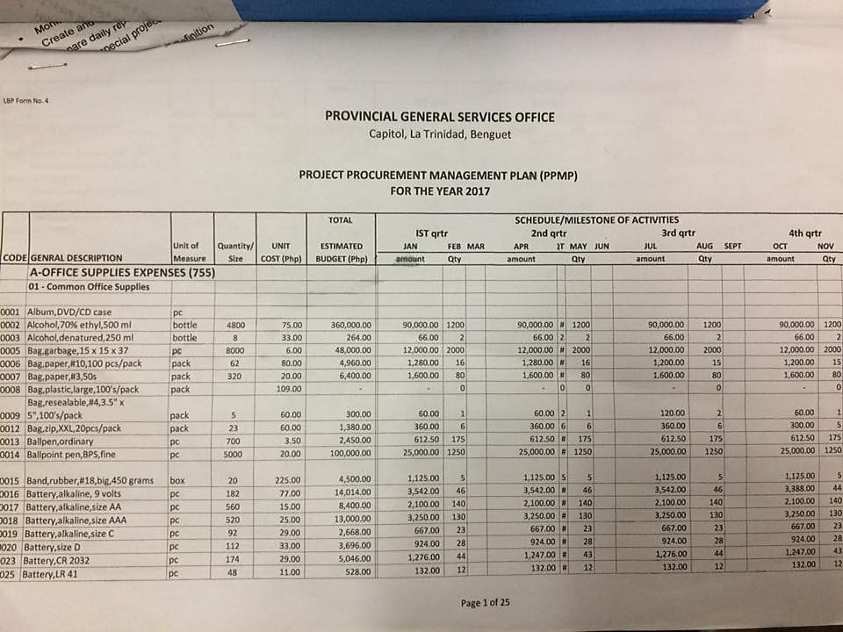

*Figure 34. PPMP*

**Purchase Order**

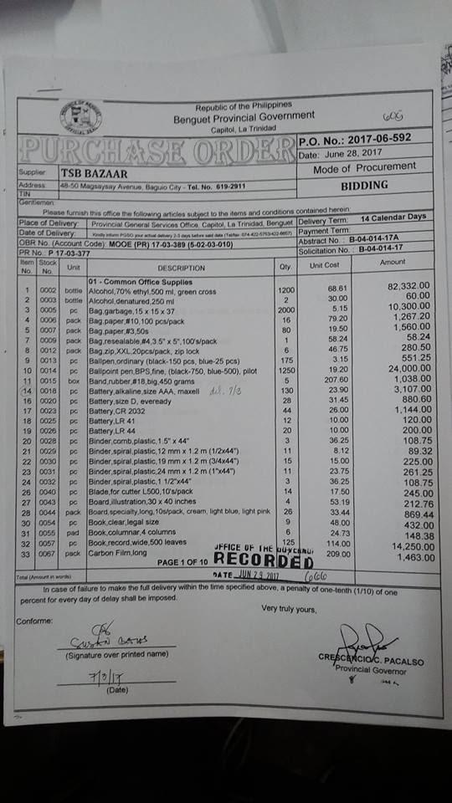

*Figure 35. Purchase Order*

**RIS – Requisition and Issue Slip**

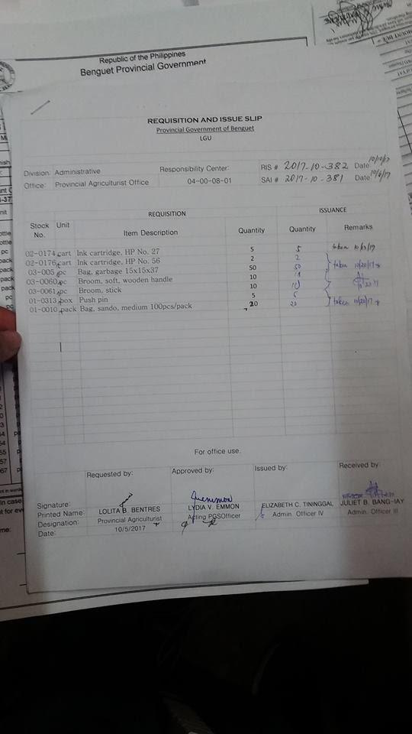

*Figure 36. Requisition and Issue Slip*

**SAI – Supplies Availability Inquiry**

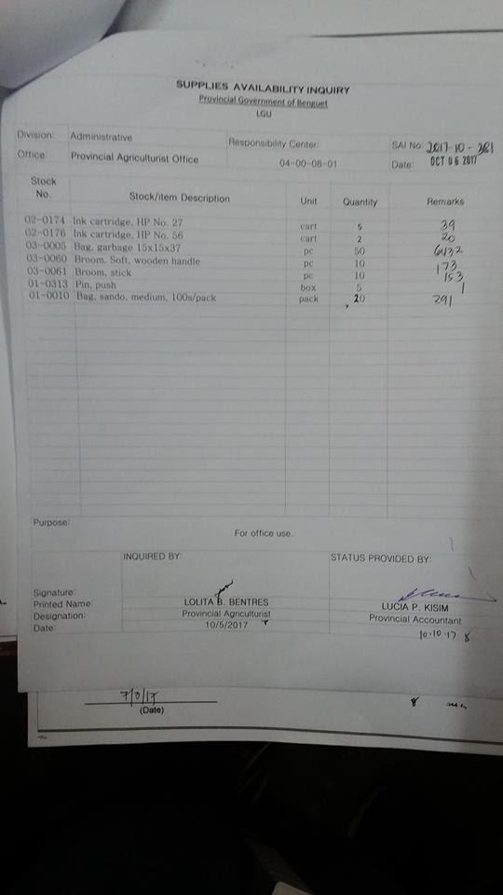

*Figure 37. Supplies Availability Inquiry*

**ICS – Inventory Custodian Slip**

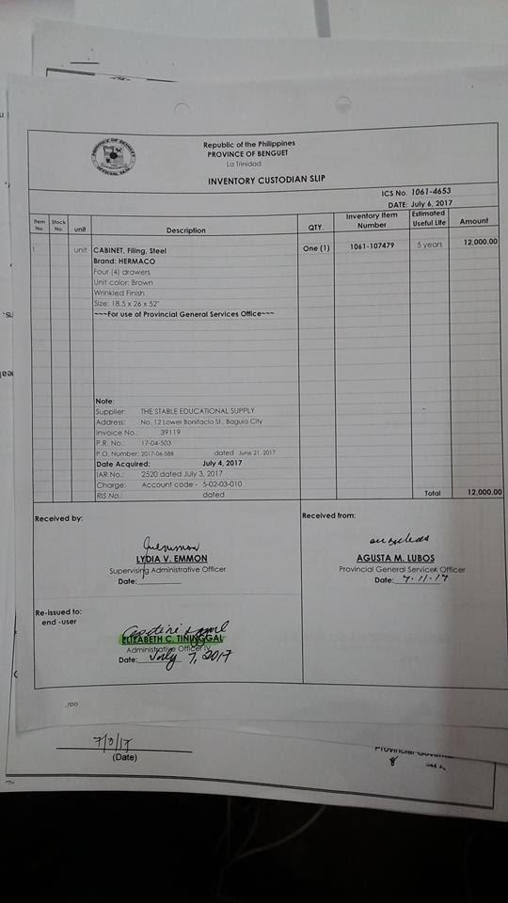

*Figure 38. Inventory Custodian Slip*

**IAR – Inspection and Acceptance Report**

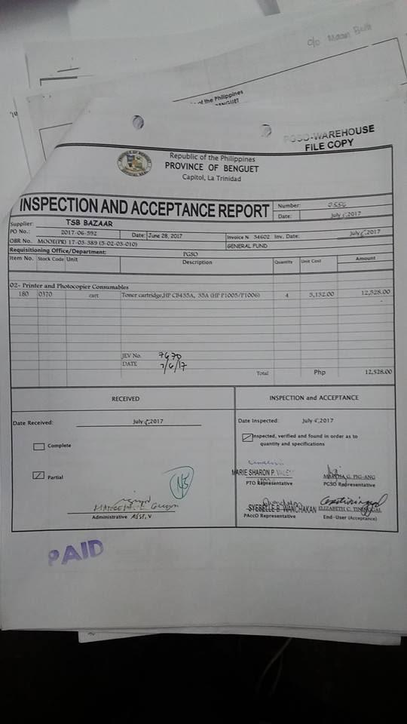

*Figure 39. Inspection and Acceptance Report*

**Stock Card**

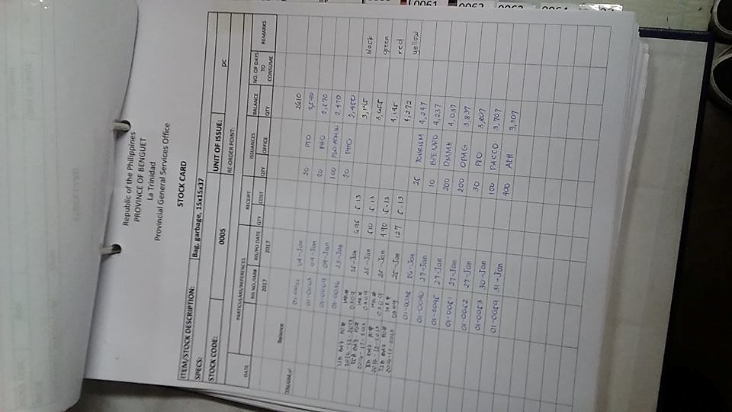

*Figure 40. Stock Card*

**Obligation Request**

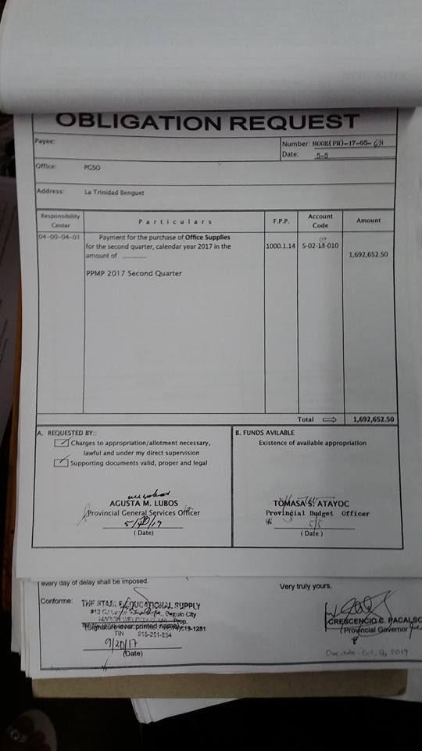

*Figure 41. Obligation Request*

**Purchase Request**

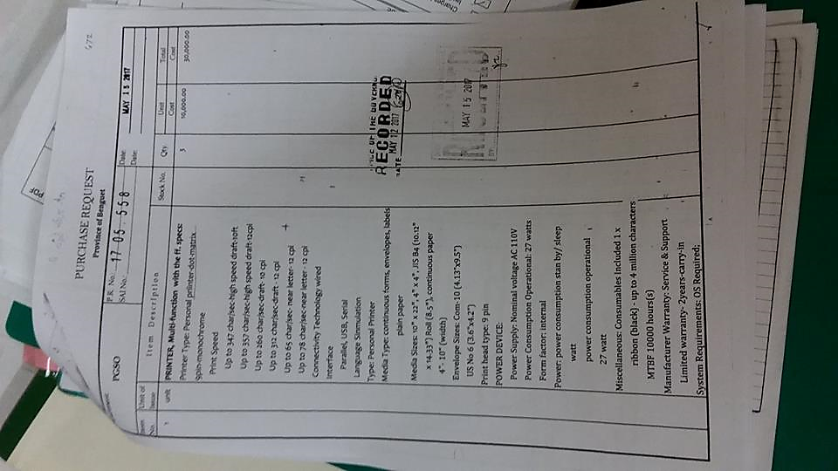

*Figure 42. Purchase Request*